Michigan One Community Credit Union
Bid Form

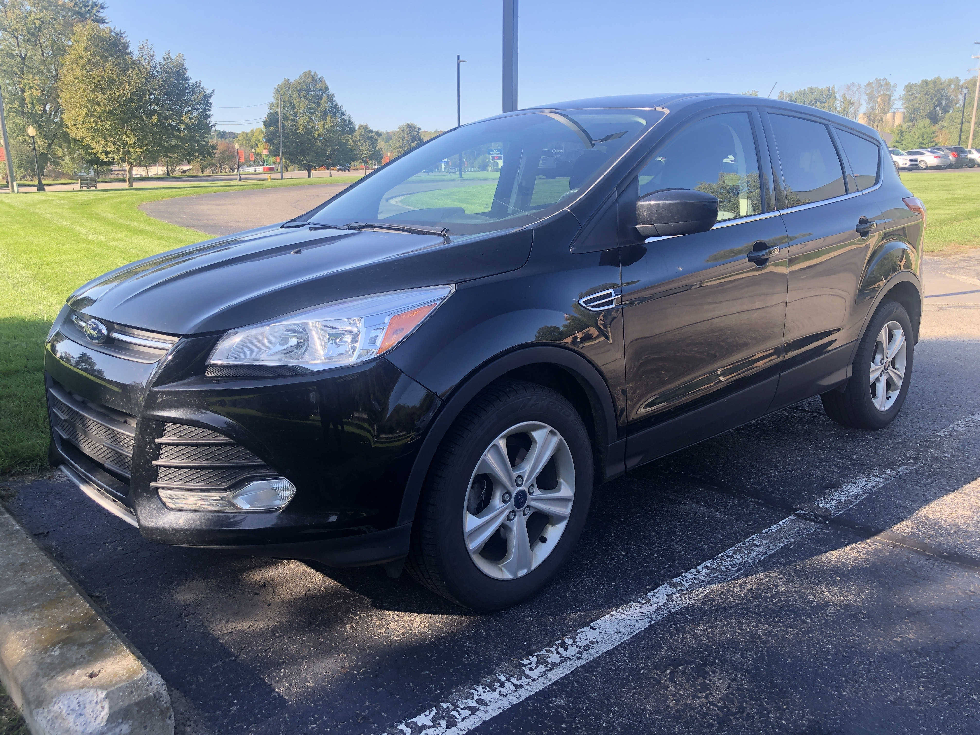
2016 Ford Escape
VIN: 1FMCU0G74GUA65209
Asking: $10,900
Minimum Offer: $10,500
N.A.D.A.: $11,350
Mileage: 97,840
*A/C *Automatic
*Backup Camera
*Bluetooth *Cloth Seats
Bid Amount: $

Your Name:
Your Address: Address 1
Address 2
City, State, Zip

Daytime Phone:

Email (optional):

Questions:

Can we pre-approve you for a loan? Yes!
Please email completed form email to: loandept@M1ccu.org

- All bids below minimum offer will not be processed or considered in anyway.
- Your bid is not binding, and may be withdrawn with no obligation.
- M1 may refuse any bid.
- All vehicles are sold “as is” and M1 makes no claims or warranties otherwise.
- All bids are reviewed on Thursdays.
- Once high bid sale is confirmed, all declined low bidders will be contacted.

